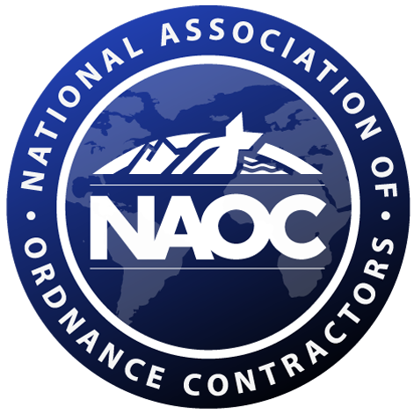
National Association of
Ordnance Contractors (NAOC)
(ESTABLISHED 22 FEBRUARY 1995)

-- Membership Application Form --

(Mail to Membership Committee; see address on page 4)

_______________________________________________________________________

The National Association of Ordnance Contractors is a tax-exempt professional association of firms who actively support and participate in the munitions response industry. Membership is open to all companies which perform Munitions and Explosives of Concern (MEC) investigations, studies, or remediation, or which perform services in a related or supporting field. Please request a copy of the NAOC's "Articles of Association" for additional information; make requests to NAOC's Member Services Chairperson (see page 4, second POC).

The basic objectives of NAOC are to represent and promote the interests of its members and the public in the field of MEC related work. These objectives include having NAOC serve as the industry's spokesman for MEC contractors; facilitating communications with governmental agencies; promoting the quality, effectiveness and safety of MEC-related work and coordinating with technology providers to focus their efforts on developments which will benefit members and clients.

NAOC's dues schedule is shown below.

Please make check payable to "NAOC".

Large Business (greater than 500 employees): $4,425
Small Business (less than 500 employees): $3,160
Very Small Business (with less than $5M in annual revenue): $1,580

Dues payment for the full year is due on or before 1 April of each membership year.
In the event that non-payment is not cured within 60 days of payment due (June 1), the member will be subject to immediate termination by the BOD, and all benefits, i.e., website, attendance at meetings, etc. will be terminated. Please refer to NAOC’s Articles of Association, Section III for Membership guidelines.

For new membership application, NAOC pro-rates membership by quarter year. For example, if the company applies in January, full yearly dues are required with the application, if applying in e.g. April, they dues are ¾ of the year, July ½ of the yearly dues etc.

Note: Members are subject to assessments as may be determined by the Board of Directors, or the annual membership dues may be changed, or both.

NAOC Membership Application Form (Cont'd)

Name of Company: ________________________________________________
Company's Address: ________________________________________________
(Corporate Headquarters) _________________________________ [please include zip code]
Company’s Homepage: ________________________________________________
Company Logo: Please submit electronically to Christian Feagans at christian.feagans@errg.com

Business Size: ________________________________________________
(according to size standards on the 1st page under dues payments:
large, small, very small?)

Note: Please make out check to "NAOC". Mail check and application to NAOC Member Services Committee (see address on page 4) or to expedite the approval process, first e-mail the application to christian.feagans@errg.com and then also mail the dues check with a copy of the application (see address on page 4).

Company's NAOC Designee: ___________________________________
Designee's Title: ___________________________________
Designee's Address: ___________________________________
___________________________________
Telephone Number(s): ___________________________________
Telefax Number(s): ___________________________________
E-mail: ___________________________________
Alternate Designee: ___________________________________
Alternate Email: ___________________________________
Note: Designee will receive all NAOC correspondence and would be the attendee at association meetings. Alternate will receive emails only.

Please tell us which company/person referred you to NAOC: _______________________

Submitted By: ________________________________________________
Authorized Signature

Printed Name, Title, Date: ________________________________________________

NAOC Membership Application Form (Cont'd)

Company Profile Information (1)

Company Name: ____________________________________

No. of Offices: ___________

No. of Employees: __________________

Estimated Annual Revenue: ___________________

Primary NAICS code: __________________ (2)

Business Category/Size: _______________________________________________ (2)
(Choose all that apply: Large, Small, 8a, HubZone, SDB (Small Disadvantaged Business), VOSB (Veteran-Owned Small Business), SDVOSB (Service Disabled Veteran-Owned Small Business), WOSB (Women-Owned Small Business), Minority-Owned Small Business (African American, Hispanic American, Native Indian American, Asian Indian American, Subcontinent-Asian American or Asian Pacific American), ANC (Alaskan Native Corporation), NHO (Native Hawaiian Organisation), HBCU (Historically Black Colleges and Universities)

Major Business Locations City/State/Zip Code (3):

________________________ ___________________ ____________________

________________________ ___________________ ____________________

________________________ ___________________ ____________________

________________________ ___________________ ____________________

(attach additional page if needed)

Existing lobby efforts or membership in organizations with lobby efforts ?

Circle one: Yes No

Point of contact for more information on lobbying efforts (name/ location/ phone number/ email):

Notes:
- Information such as estimated revenue, approximate number of employees/offices, and major office is requested to provide a profile of the membership so that we may better represent NAOC. Information may be approximate (+/-10%).
- Primary NAICS code – please provide one single NAICS code that best represents the work your company does that is NAOC related. The NAICS code and business category/size will be shown on NAOC’s website under the members page that can be viewed by the public
- Major business locations are those with approximately 100 employees or more. For firms with less than 5 offices meeting this criterion, please identify your 5 largest offices not including the corporate headquarters office identified on page 3. Zip codes are essential for the information to be utilized effectively (e.g., to determine congressional districts).
NAOC Membership Application Form (Cont'd)

NAOC ADDRESSES:

1. Submit an Acrobat PDF copy of the filled out Applications and copy of the Dues Payment check via e-mail to:
Ms. Feagans is responsible to get the application approved by the NAOC Board of Director

Christian Feagans
NAOC Member Services Committee
c/o ERRG, Inc.
Tel.: (925) 331-8686 (office)
Cell: (720) 951-5855
e-mail: christian.feagans@errg.com

Make check payable to "NAOC".

2. Submit the Dues Payment Check to the Treasurer with the Original Application via mail to or contact the Treasurer for payment via Credit Card:
Ms. Lemley is responsible for processing the dues payments.

Karen Lemley
NAOC Treasurer
c/o NAEVA Geophysics, Inc.
PO Box 7325
Charlottesville, VA 22906
Tel.: (434) 978-3187 x223
e-mail: klemley@naevageophysics.com

3. For Questions about Membership or to Request Additional Information:

Nicole Sharkey
NAOC Membership Services Chair
c/o Weston Solutions, Inc.
1400 Weston Way
West Chester, PA 19320
Tel.: (610) 701-3425 (office)
Cell (434) 996-7650
e-mail: nicole.sharkey@westonsolutions.com

